Day 8 Lab Assignments

- Use AJAX to retrieve users data, and display: First Name, Last name and address and phone from the following test web API: https://jsonplaceholder.typicode.com/users
  - Make a textbox where the user can enter user ID, and press display and then display the user with the given ID.

Bonus:
- [Big Bonus] Create a simple E-commerce website from 2 pages:
  - First page displaying products (use this API: https://fakestoreapi.com/products) in a list like the following image:
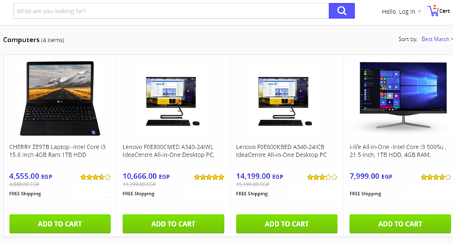
  - Use cookies or local storage to store the ID of the product, when user clicks (Add to Cart).
  - In the first page add a link (like in the upper part of the previous image) to the second page (Shopping Cart), that lists the products added by the user (user can edit items count and can delete items), and calculate the total price and display it on the page (You’ll need to run your product from any local server so you can access cookies or local storage in all website page, for example you can use live server extension in Visual Studio code).
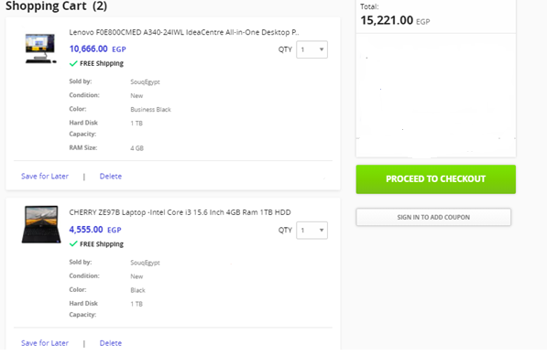
  - Make a details page for each product, when opened display all details of the selected product (Use this API: https://fakestoreapi.com/products/id).
  - Congratulations, you just finished your first pages in a simple E-commerce websiteJ.
- Use CSS to style the SD courses JSON data on the page.
- Convert Given XML File, to JSON Object (in a variable inside HTML page), and Print its data in the page.
- Read the SD courses JSON file using Ajax, and print its data on the page.
- Read the given XML file using Ajax, and write its data to the page.
- Do any missing assignments or bonus assignments in previous days.
- Complete on your simple E-commerce website.
<Script>document.write(“Thank YOU”) </Script>

